**why are my Xfinity channels in Spanish revert them 800 S4**

**Introduction:**

Xfinity is a renowned telecommunications company that offers inline streaming, internet, etc. Xfinity came under the scanner recently due to a software bug in their system. The bug revised all settings and audio language to Spanish. Users across the world who were using Xfinity’s subscription faced this issue and the majority took to the internet to find a solution for this bug.

**How to revert the Spanish channels:**

You might need to reset your audio accessibility settings if you try to switch to English but your Xfinity device instead switches to Spanish.

To your device's language settings:

On your remote, press the Xfinity button.

Open 'Settings' by navigating there.

Select "Audio Language Reset" under "Audio language" by scrolling down.

Your device's language will be reset to its default setting, which in the case of Xfinity is always English. Restarting your device should make the language changes visible if they don't happen right away. If that doesn’t work too, follow these steps:

**1) Changing language from the settings on the app:**

Altering the language settings on the Xfinity app is another option. Click the "options" tab after opening the Xfinity Connect interface (gear icon). Make sure the 'Mail' tab is selected in the settings. Look for the language drop-down menu on the basic settings page. Before clicking it to make the changes, ensure that the language is selected in English. After the changes take effect, your language preferences should be set to English. The settings for other services, such as voice and text, remain unchanged.

**2) Power cycling:**

Power cycling the device is another option if the adjustments you made in the settings didn't work for you. Simply switch the gadget off, unhook it from the power source, and allow it to drain for up to a minute. This guarantees that there is no remaining power in the device and causes it to soft-reset. Reconnect the device, turn it back on, and check to see if the appropriate audio adjustments have been made after a minute.

**3) Verifying accessibility settings:**

The problem is essentially a software flaw that causes the language to switch back to Spanish. You must visit the accessibility settings on your device to correct it. On your Xfinity, remote, use the "B" button to view the accessibility settings. Disable the "Video description" option by scrolling down and looking for it. This setting is typically used by visually impaired people, so the viewer is described what is on the screen by the device. For some reason, if the "Video description" option is turned on, a glitch causes your Channel's language to change and go back to Spanish.

**4) Resetting the cable box**:

The next best option is to hard reset the device if the power cycle approach doesn't work. If your Xfinity cable box isn't working, you can try this. Turn off your gadget, but keep the power cord attached, to accomplish this. Use a safety pin or a sim ejection tool to push and hold the reset button on the Xfinity device for about 30 seconds. After doing this, let your device start-up and carry out the initialization procedure. Scroll through your channels after this is finished, and the language settings ought to be in effect at this point.

**5) Using the Xfinity remote to change the audio language:**

Voice control is a feature of more recent Xfinity remotes, giving you another way to change the language of your menu. This makes it possible for Spanish-speaking Xfinity customers to use the speech functions of Comcast's remote in their language. It is pretty simple to change it back if you want to or if you unintentionally turned on the Spanish setting. Press the Xfinity button and choose the gear symbol to switch the Xfinity menu for the voice remote from Spanish to English. Use the down arrow to move to Voice Search Language after selecting OK. You'll be asked to switch the Xfinity menu from Spanish to English when you click OK there.

**6) Modifying the Playback Controls' Audio Option:**

The playback settings on your remote also let you adjust the audio settings. Look for the "Audio Options/SAP" tab by pressing the "down arrow" on your remote. When you choose it, a list of the many languages that Xfinity transmits on their network will appear. Apply the modifications by selecting English from this list. The channel or program you want to view must, however, be available in many languages.

**Conclusion:**

It's best to contact Xfinity support with your complaints if, by chance, none of the aforementioned workarounds were successful for you. They will be more equipped to identify the problem and return with a long-lasting fix. Use the solutions listed above and keep a watch out for any potential software updates if your Xfinity channels are playing in Spanish but it keeps resetting the settings. To avoid needless interference on both devices, you can also check to see whether your TV and Xfinity are not exchanging any settings.

**FAQs:**

**1. How to find the SAP button in my Xfinity remote?**

Your Xfinity remote's down arrow should be used to move left and then you will find the SAP option.

**2. Can all the channels which have been changed to Spanish be reverted?**

Yes, all the channels which have been accidentally changed to Spanish can be reverted to their original language using the methods mentioned above.

**3. Is there any way to change my Xfinity remote settings or options?**

Yes, you can modify the settings. To reconfigure and modify settings for your Xfinity or Comcast remote, hold down the setup button on your remote.

**Spinmenot screenshot:**

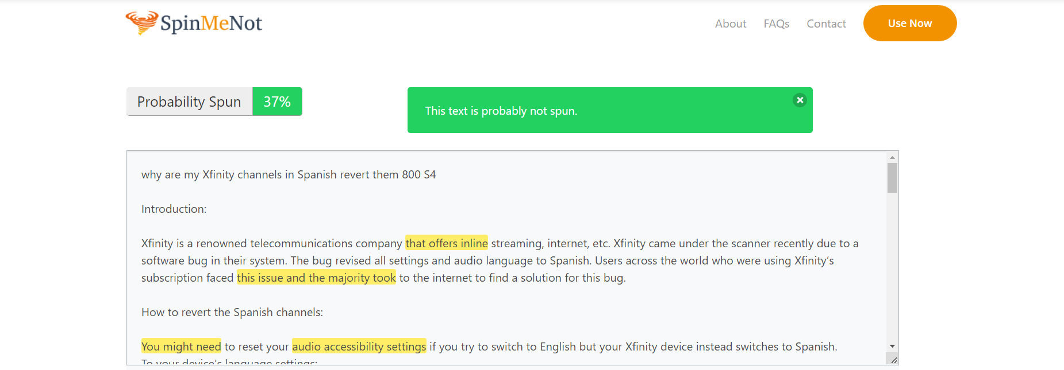

**Grammarly screenshot:**

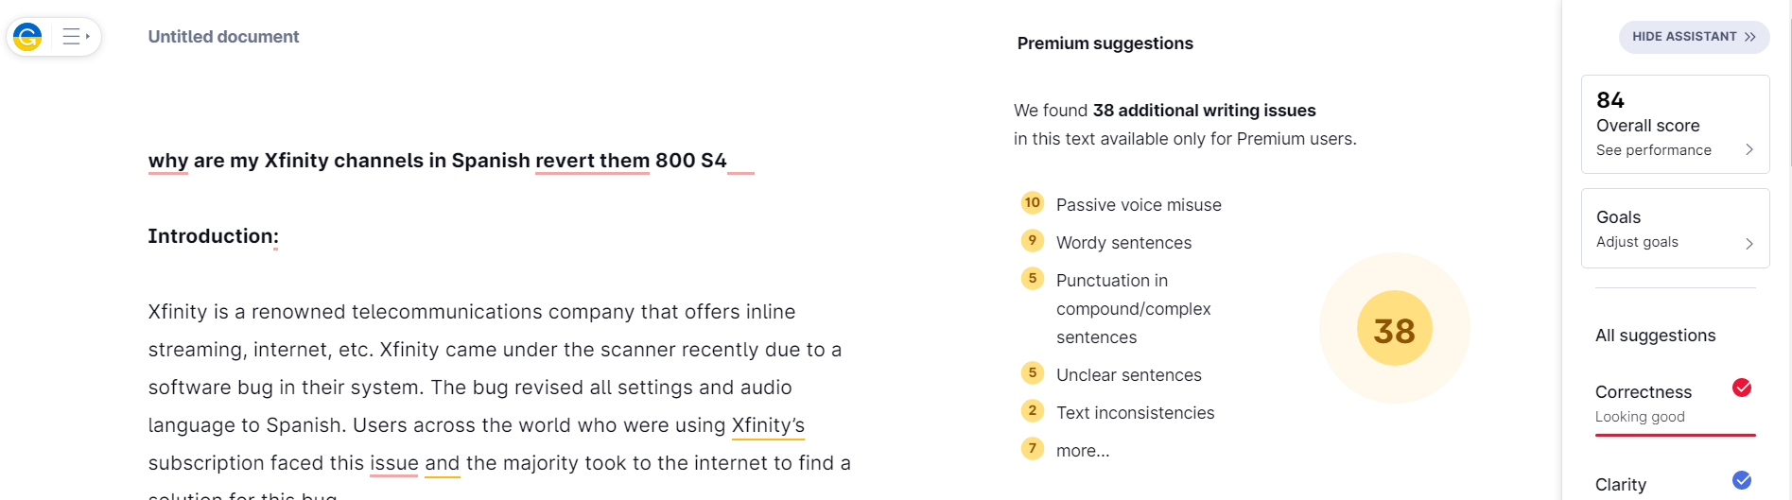

**Quetext screenshot:**

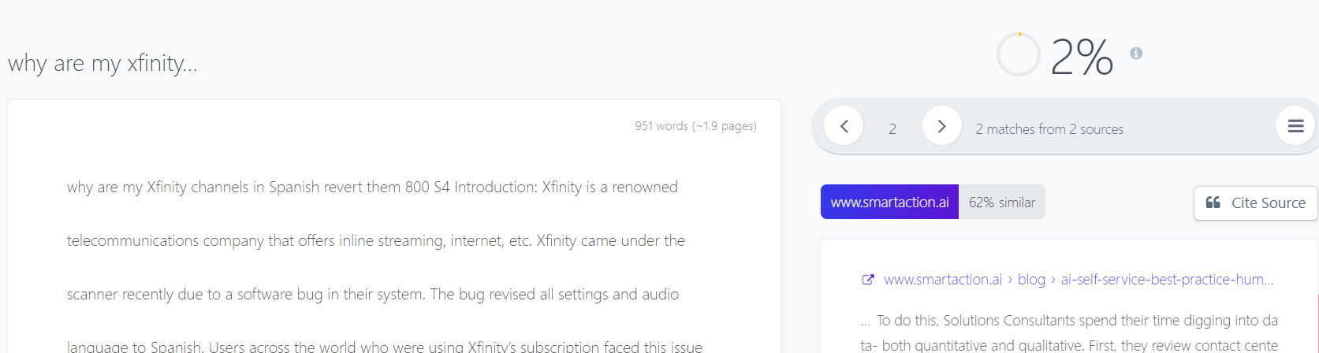

**-An Article by Sanjay M.**